Notes for Delegates
Boao Forum for Asia Annual Conference 2012

The Secretariat of the Boao Forum for Asia (BFA) extends a warm welcome to all the delegates of the BFA Annual Conference 2012 to be held April 1-3 in Boao, Hainan, China. This document is designed to provide the necessary assistance for you and facilitate your participation in the conference.

Registration and Accreditation:

Register to the Conference: Conference registration can be done online at www.boaoforum.org , or you may also complete the registration form and send it back to the Secretariat of the Boao Forum for Asia via email or fax. Upon receiving your registration request, Secretariat staff shall contact and assist you on registration details.

Registration Fee: The registration fee for delegates covers participation in all conference events, documentation, post-conference-publication and transportation from Haikou Meilan Airport to delegate hotels and from there to Peilan Bridge Registration Center, exclusive of participants’ travel, accommodation and other personal expenses. The registration fee for spouse covers the cost of accreditation, the local shuttle service and social dinners, but no access to conference sessions and luncheons.

Cancellation Policy: Request for cancellation shall be made in writing by fax, email or mail. 5% processing fees will be charged if the request is received before March 1 , 20% processing fees if the request is received between March 2 and March 25, and no refund after March 25.

Registration Deadline: The cut-off date for application is February 10, 2012. Any registration after the deadline will not be entertained.

Confirmation of Registration: Upon receiving your registration application from online/by email/ fax, the BFA Secretariat staff shall contact you further assisting you with the registration. Once the registration process is completed, a Letter of Confirmation will be issued to you by email/fax. Please keep the Letter of Confirmation with you since this will be used for booking your hotel rooms and onsite registration.

Confirmation of Accreditation: The accreditation will be done by local Security Authority. For those accredited, the security authority shall prepare their conference passes according to the information provided during registration.

Conference Pass/Pack Collection & Onsite Registration: Each delegate of the BFA AC 2012 will receive a conference pass and a pack upon onsite registration at Peilan Bridge Registration Center. Delegates shall pick up their conference passes and packs before checking into their hotels. Due to security requests, delegates will be denied access to conference venue and designated hotels without wearing a valid conference pass. Personal ID (passport or national ID card) and the Letter of Confirmation provided by BFA Secretariat are requested for onsite registration. Information of lost and damaged passes must be immediately reported to the Conference Information Center (located at BFA Hotel).

Working hours of the conference service desks are as below:
Reception Desk at Haikou Meilan Airport:
08:00 am - 02:00 am, March 31 – April 2 (Saterday to Monday)
Peilan Bridge Registration Center:
08:00 am - 04:00 am, March 31 – April 2 (Saterday to Monday)
Information Center at the BFA Hotel:
07:00 am - 24:00pm, March 31 – April 3 (Saterday to Tuesday)
05:00 am - 14:00pm, April 4 (Wednesday)

Location of the Accreditation and Registration Center at Peilan Bridge, the only passage connecting Dong Yu Island, where the Boao Forum for Asia Conference Center and the BFA Hotel are located, with the rest of Boao town:
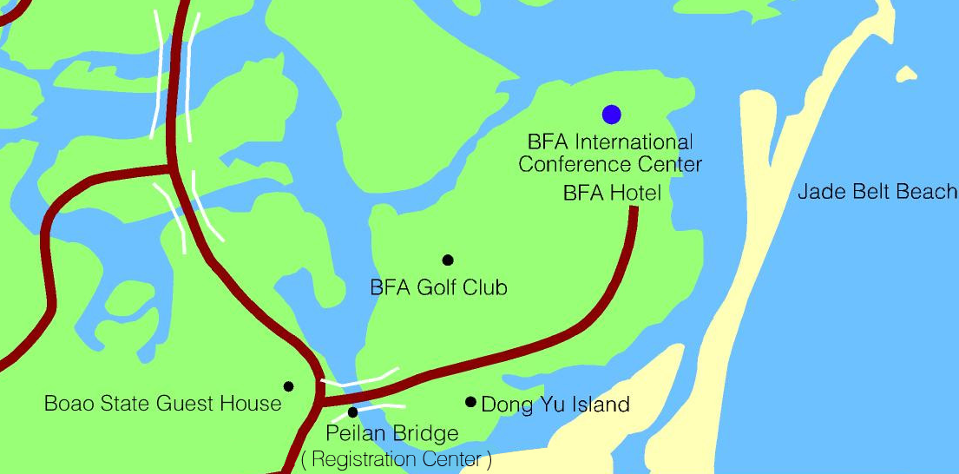

Conference Venue:

The BFA Annual Conference 2012 will be held at the BFA International Convention Center (ICC) under the management of BFA Hotel (previously known as Sofitel Boao Hotel). The map of conference venue can be found at http://www.boaoforum.com/Html/AC2012/dituEN.asp.

Program:

Please visit http://www.boaoforum.org for the updated program of the conference.

Hotel Accommodation:
The designated hotels for delegates include: BFA Hotel, Ramada Hotel and Suites Boao, Boao Golden Coast Hot Spring Hotel, Boao Asia Bay Club Hotel, Boao Jinjiang Spa Hotel and Boao Qianzhou Bay Resort. BFA Hotel is linked with the Conference Center by a corridor. The other hotels are about 10-15 minutes’ drive from the Conference Center. During the Annual Conference, shuttle bus service is available. The booking of BFA Hotel and Boao Golden Coast Hot Spring Hotel is arranged by the BFA Secretariat for speakers, sponsors and some BFA members. Delegates shall clear all expenses incurred at the hotels when checking out. The booking for other hotels shall be done by delegates themselves directly with the hotels using the hotel booking form provided by the BFA Secretariat.
BFA Hotel(★★★★★) :
Address: Dongyu Island, Boao Aqua polis, Hainan Province, 571434 QIONGHAI, CHINA
Tel: +86-898-6296 6888 Fax: +86-898-6296 6688
Golden Coast Hot Spring Hotel (★★★★★) :
Address: 8 Golden Coast Avenue, Boao, Hainan, 571434 QIONGHAI, CHINA
Tel: +86-898-6277 8888 Fax: +86-898-6277 8899
Ramada Hotel and Suites Boao(★★★★☆) :
Address: No. 9 Longbow Avenue, Boao Town, Qionghai City, Hainan, 571434, CHINA
Tel: +86-898-6277 0000 Fax: +86-898-62777988
Boao Jinjiang Spa Hotel(★★★★)
Address: No. 1 Jinhai'an Avenue, Boao, Qionghai, Hainan, CHINA
Tel: +86-898-62778588 Fax: +86-898-62778128
Boao Qianzhou Bay Resort (★★★★☆) :
Address: Boao, Hainan, QIONGHAI, CHINA
Tel: +86-898-66666663, Fax:+86-898-62779776,
Boao Asia Bay Club Hotel :
Address: Boao, Hainan, QIONGHAI, CHINA
Tel: +86-898-62708688, Fax: +86-898-62708618
Travel Arrangements:
Air Travel to Haikou Meilan International Airport: Participants should make their own travel arrangements. Haikou Meilan International Airport and Sanya Phoenix International Airport are both reachable from all major airports within the country and in Asia including Beijing, Shanghai, Hong Kong SAR, Guangzhou, Taipei, Singapore, Hanoi etc. Haikou Meilan International Airport and Sanya Phoenix International Airport are 20-35 minutes away from conference hotels and conference venue by high speed railway and 1.5-2 hours away by car.
Ground Transportation: Shuttle service shall be provided to all delegates from Haikou Meilan International Airport to Peilan Bridge Registration Center and from there to conference designated hotels at Boao from March 31 to April 2. Shuttle service shall also be provided to take delegates from designated hotels to conference venue for conference programs and social events. Shuttles shall run at regular intervals throughout the annual conference. If delegates wish to arrange their own ground transport, please inform the Secretariat with your car plate number before March 1 so that a vehicle pass can be prepared for you. For car rental service, please contact the following:
Mr. Zhang Dajiang
COSCO Boao
Tel：+83-13976098627, 13876215552 Fax：+86-898-62966016
Email：zhangdajiang@coscoboao.com
Visa: If you need a visa to enter the People’s Republic of China, we can provide formal invitation letter to facilitate the application. With the invitation letter and other necessary documents as requested by the local Chinese embassy or consulate, you will be able to apply the visa for entering China. Please call your contact person at the Secretariat for the invitation letter.
General Information
Dress Code:
Business attire is required for all meetings and banquets. BFA T-Shirts（received at Peilan Bridge Registration center）or other casual attire is suggested for outdoor activities.
Working Languages of the Conference：
Simultaneous interpretation will be available in Chinese (channel 1) and English (channel 2) during all sessions. Russian (channel 3), Japanese (channel 4) and French (channel 5) will be available at Opening Ceremony as well.
Internet Access in Hotels ：
Internet Access is provided in the rooms of BFA Hotel, Golden Coast Hot Spring Hotel and some rooms of Jinjiang Hot Spring Hotel and Ramada Hotel and Suites Boao. Please contact the receptions of hotels for details. Wireless access is available in Boao Kempinski Hotel. Delegates may consult the hotel regarding the usage of this service. Wireless access is available at BFA International Convention Centre and its vicinities. Participants may purchase wireless Internet cards at hotel business centre.
Ticket Service
Delegates and journalists who need to purchase air tickets, change itinerary or confirm return flights should contact the business centre of following hotels:
Business Centre, BFA Hotel
Hours: 08:30 - 23:30
Tel: (86-898) 6296 6888 ext. 7218
Fax: (86-898) 6296 6999
Business Centre, Gold Coast Hot Spring Hotel
Hours: 08:30 - 23:00
Tel: (86-898) 6277 8888 ext. 3620/3637
Fax: (86-898) 6277 8899
Telephone
The area code of Hainan Province is 0898. Domestic and international long distance services are available in all hotel rooms, but deposits are required (to be paid at hotel reception desk) to use such services.
Prepaid SIM cards for mobile phones (GSM and CDMA) are sold at the business centre of each hotel (only cash in Chinese currency (RMB) is accepted).
Weather
Boao has a tropical marine climate. The temperature during the time of the Conference is within the comfortable range between 25 Celsius and 35 Celsius.
Currency
The local currency is the Chinese Renminbi ( RMB or ￥). The Chinese RMB is pegged to the US dollar at a rate about US$1=RMB 6.6. The exchange rates are decided depending on exchange rate of that day issued by People’s Bank of China. Currency and travelers’ checks can be converted into RMB in the hotels. Credit cards such as Visa, MasterCard and American Express are accepted by all hotels.
Voltage
The voltage in China is 220v. Sockets in the hotel rooms are of 2-phase and 3-phase (MY-2204) types.

Hainan Province
Located at the southernmost tip of China, Hainan Province comprises the island of Hainan and its adjacent islets. It covers an area of 35,300 square kilometers with a population of 8.45 million. Besides the Han nationality, there are 53 ethnic minorities inhabiting in Hainan, among whom, the Li, Miao and Hui people are aboriginals. With a population of over 1.2 million, the Li is the most populous ethnic minority. Hainan has a tropical and maritime monsoon climate. Its annual average temperature is between 22℃ to 26℃ and precipitation 1,500 to 2,000 mm. In 2008, the province’s GDP stood at RMB 146.6 billion, an increase of 9.8% over the previous year, and its per capita GDP was RMB 17,175 (or USD 2,514), an increase of 8.7% over the previous year.
Hainan, positioned in the center of the Asia-Pacific economic rim and on the major international marine routes in South China Sea, is one of the three major home provinces of overseas Chinese. Hainan has a coastline of 1,528 kilometers and 68 natural harbors. The province is endowed with abundant natural resources and 57.1% forest coverage. Hainan is among the places with the richest sub-region bio-diversity and a major production base of tropical cash crops, tropical fruits and season-reversed vegetables in China. Hainan also owns considerable maritime fishery resources. It has proven reserves of 67 mineral resources and rich oil and natural gas resources.
Hainan Province has beautiful natural landscape and is one of the seven most famous tourism destinations in China. Hainan was designated as China's first ecological demonstration province in 1999. Both its green coverage rate and per capita public green area are higher than the national average. Haikou was entitled the "National Model City of Environmental Protection", and Sanya the "Top Tourist City of China" and the "National Garden City". In 2008, inbound tourists were 20.60 million person times in Hainan, up 10% over 2007, among which inbound overseas tourists were 979,300.
Hainan Province is well developed in land, maritime and air transportation. Besides the round-the-island highway network, Hainan has Yuehai Railroad which links Hainan and the mainland. Hainan has opened 24 harbors and 16 deep water berths for ships at and above 10,000 tons. Hainan's annual cargo throughput stood at 45.11 million tons. Haikou Meilan International Airport has become one of the eight largest air terminals in China.
Hainan's exchanges with the outside world become increasingly frequent. So far it has established friendly ties with 19 foreign provinces and states including Hawaii State of United States, Crimea Autonomous Republic of Ukraine, and Prince Edwards Island Province of Canada. Haikou City has established sister relations with 7 cities including Saint Nazaire City of France and Oklahoma City of United States. Sanya City also has 7 sister cities in the world.

About Boao
Located on the east coast of Qionghai City, Hainan Province, Boao is centered at latitude of 19.3o north and a longitude of 110.5o east. Facing the South China Sea on the east, Boao lies 17km to the east of Qionghai City’s Jiaji Town, 105km to the south of the provincial capital, Haikou City, and 200km to the north of the famous resort Sanya City.
Renowned for its beautiful scenery, Boao is situated on the estuary of the famous Wanquan River. Here the Wanquan, Jiuqu and Longgun rivers converge into the South China Sea and are met by three islands: Dongyu, Shapo and Yuanyang. The harmonious synthesis of the sea with the city’s rivers, lakes, mountains, islands, coconut forests, fields, sandy beaches and hot water springs provides us with a wondrous landscape of miraculous proportions.
Since the inauguration of the Boao Forum for Asia in February 2001, this spectacular land was chosen as the permanent headquarters for the famous international organization - Boao Forum for Asia. The annual conference of BFA is a platform for international and Asian political leaders, businessmen and academic scholars, to communicate and seek cooperation for the common good and development of Asian countries.

